**Jemma Johnston**

**Cohort E20**

**PDA - Implementation & Testing Unit**

**IT:1** - Demonstrate encapsulation in a program

**IT:2** - Use of inheritance in a program

**IT:3 Demonstrate searching data in a program. Take screenshots of:**

● Function that searches data

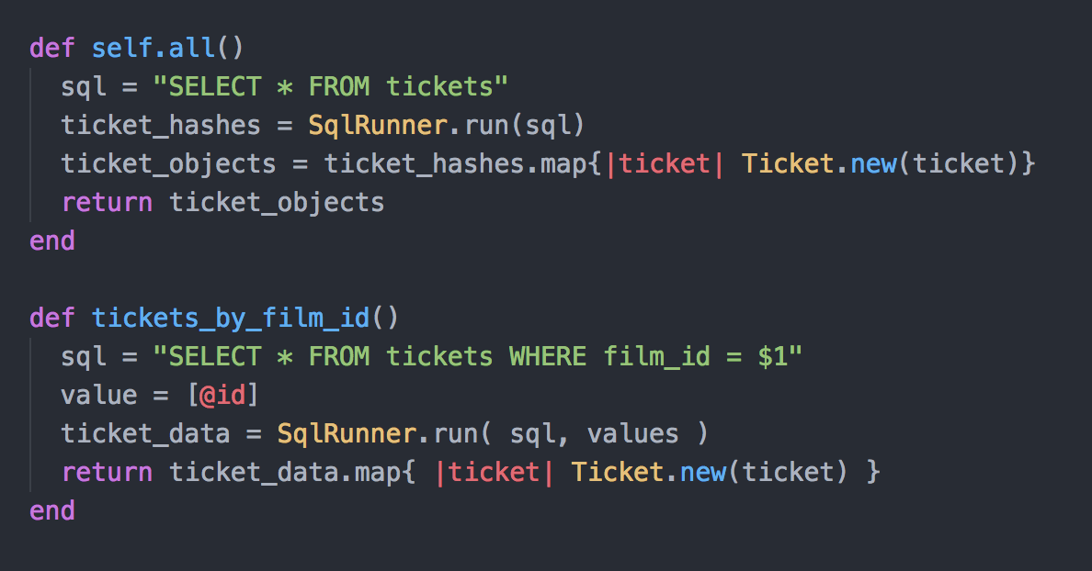

● The result of the function running

**IT:4 - Demonstrate sorting data in a program.**

Take screenshots of: ● Function that sorts data ● The result of the function running

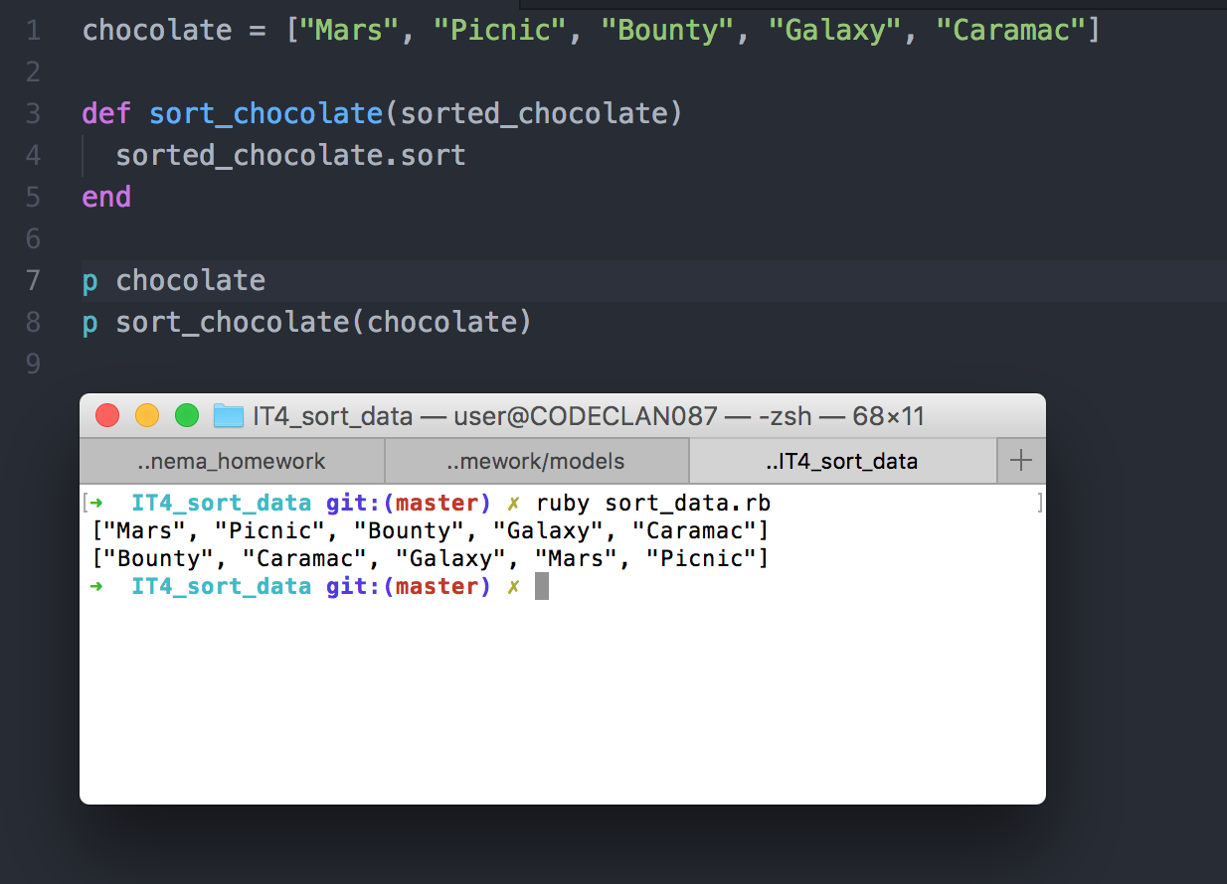

**IT:5** - Demonstrate the use of an array in a program

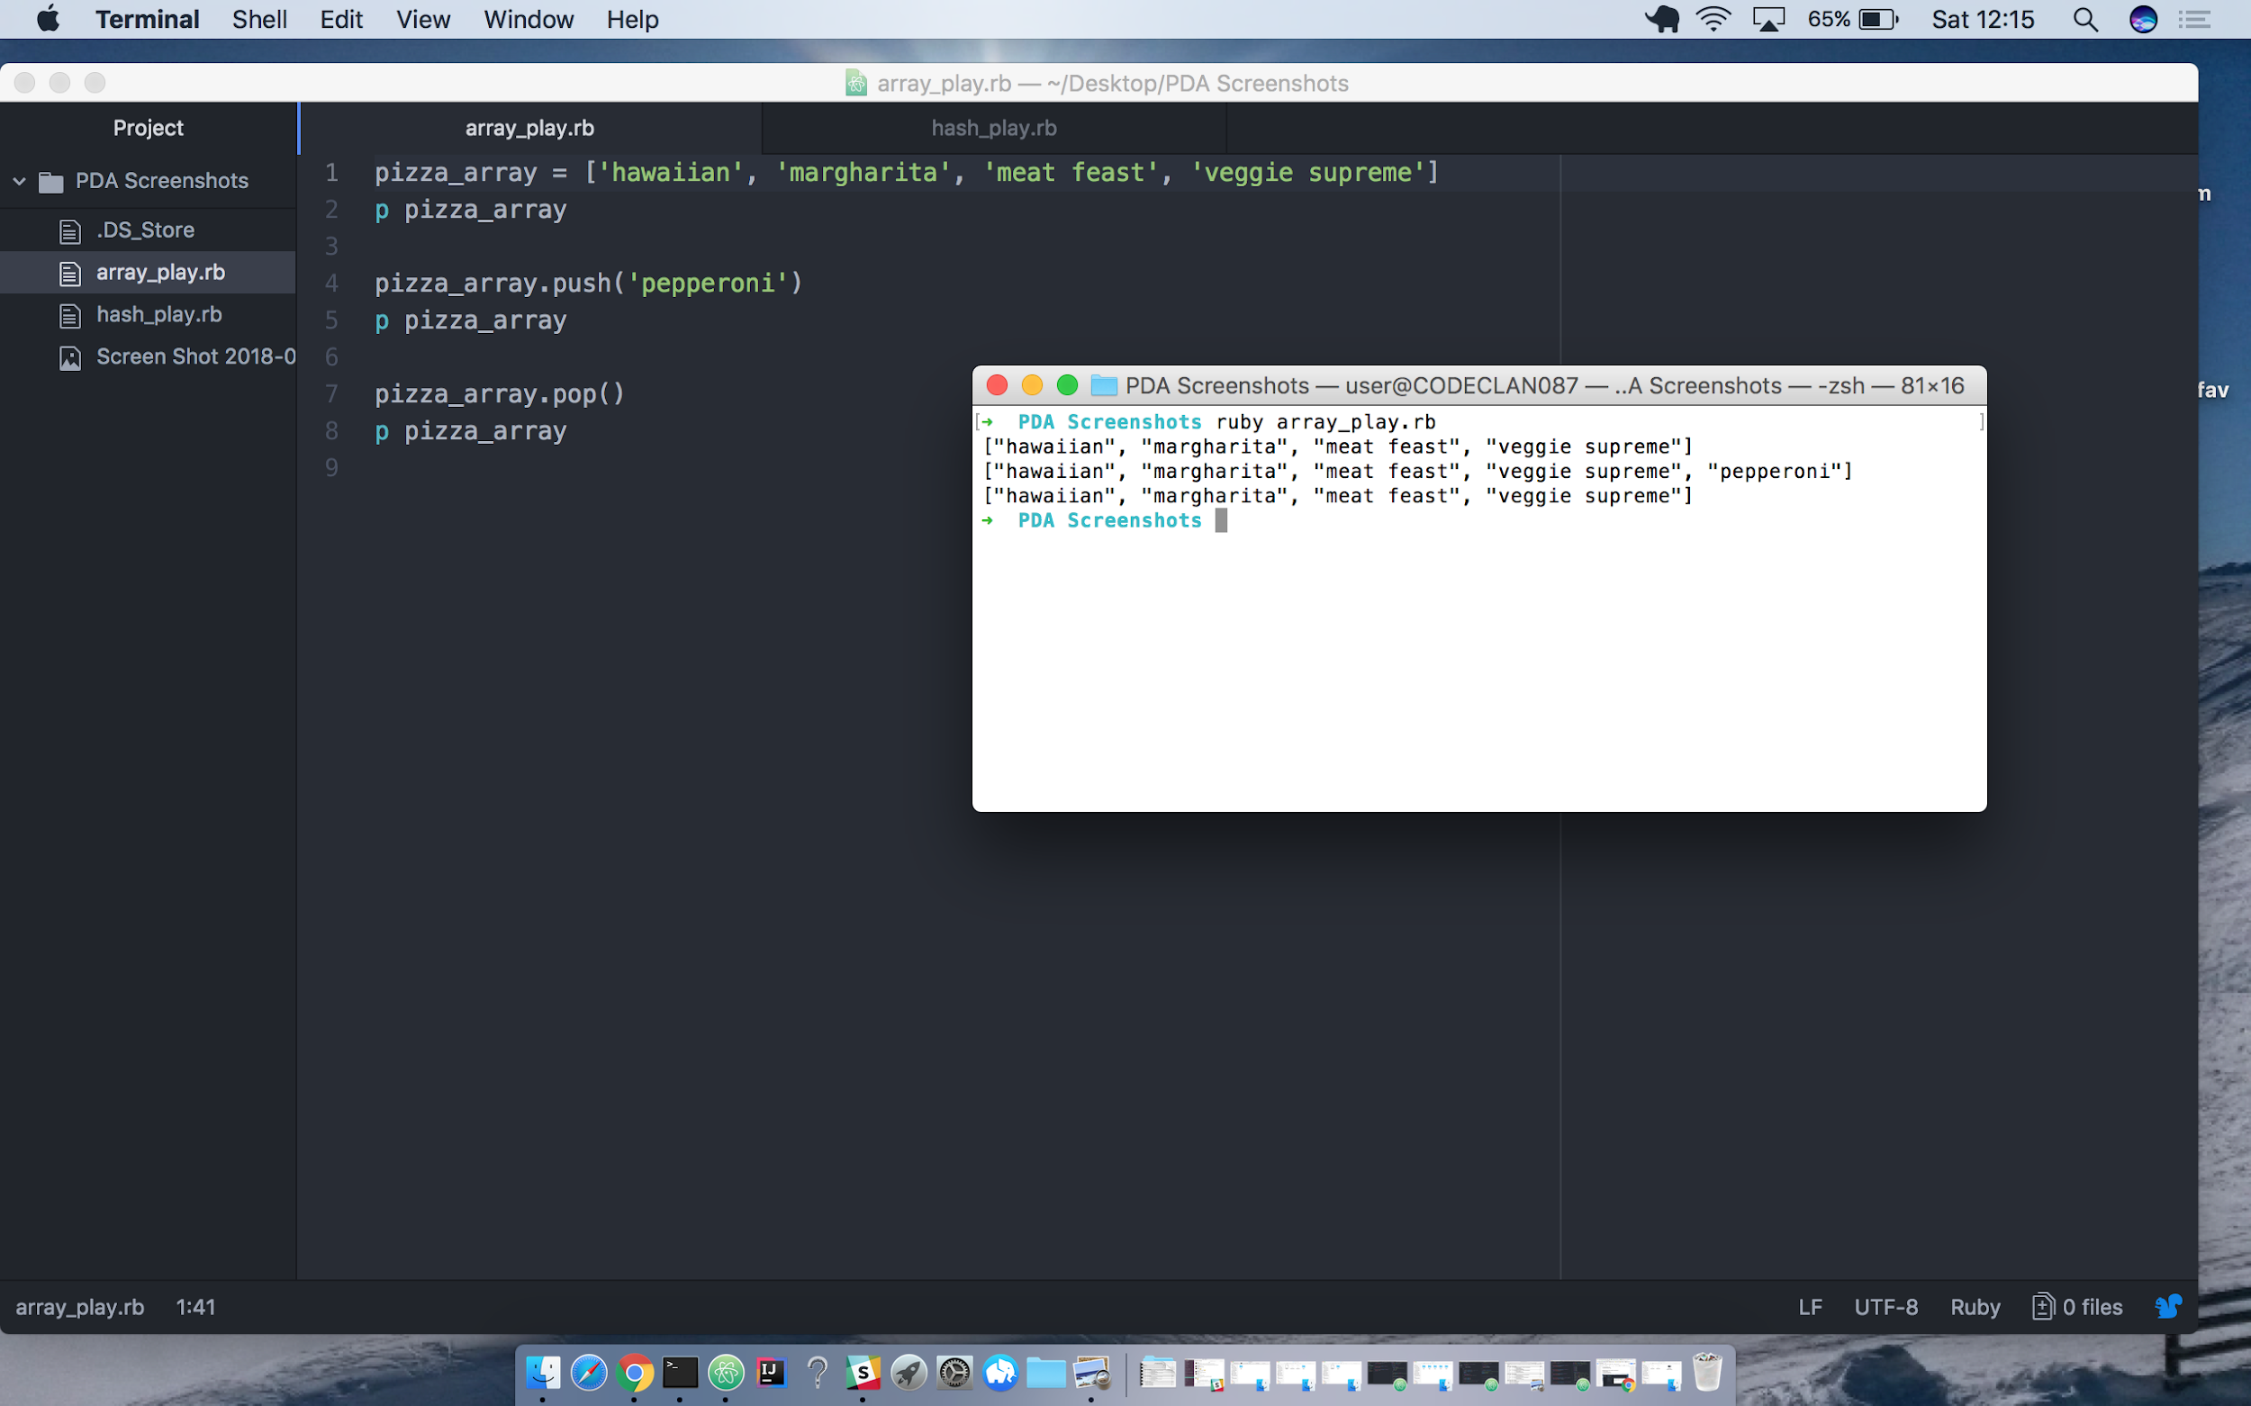

**IT: 6 - Demonstrate the use of a hash in a program**

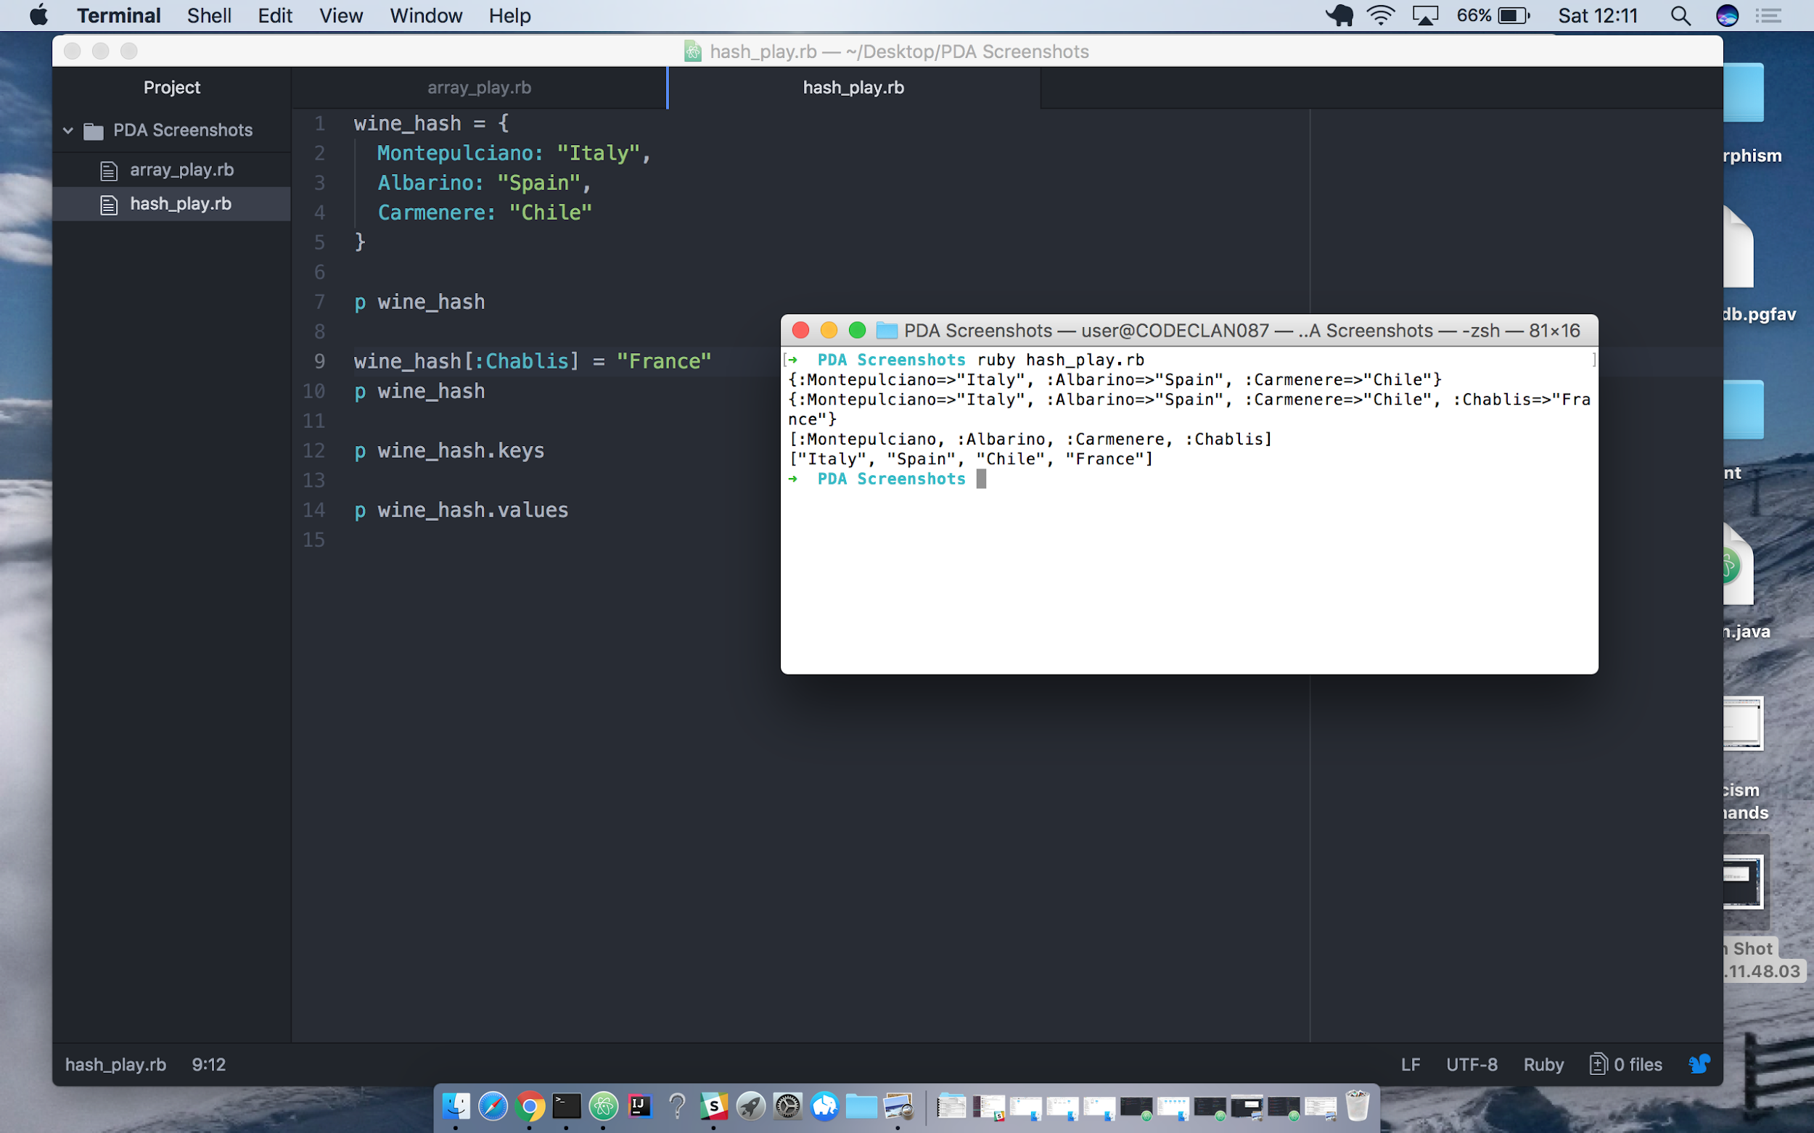



**Coding exercise 1: Static and Dynamic testing task A**

**IT:7**  Demonstrate the use of Polymorphism in a program.

**IT:1** Take a screenshot of an example of encapsulation in a program.

**IT:2** Take a screenshot of the use of Inheritance in a program. Take screenshots of:

* ● A Class
* ● A Class that inherits from the previous class
* ● An Object in the inherited class
* ● A Method that uses the information inherited from another class.